Header (Nav Bar)
Index.html

Hero-header

Highlight-grid
Highlight-card Highlight-card

Highlight-card
Highlight-card
Footer

Gallery.html
Header (Navbar)
Room card
Room grid
Room card
Room card

Food grid
Food card
Food card
Food card
Food card

Footer

Gallery.html
Header (Navbar)

Header-hero
Highlight-grid
Highlight-card

Highlight-card
Highlight-card
Highlight-card
Highlight-card
Highlight-card

Footer

Reservation.html
Header (Navbbar)

Carousel |  | Reservation

Footer

Login.html
Header (Navbar)

Login

Footer

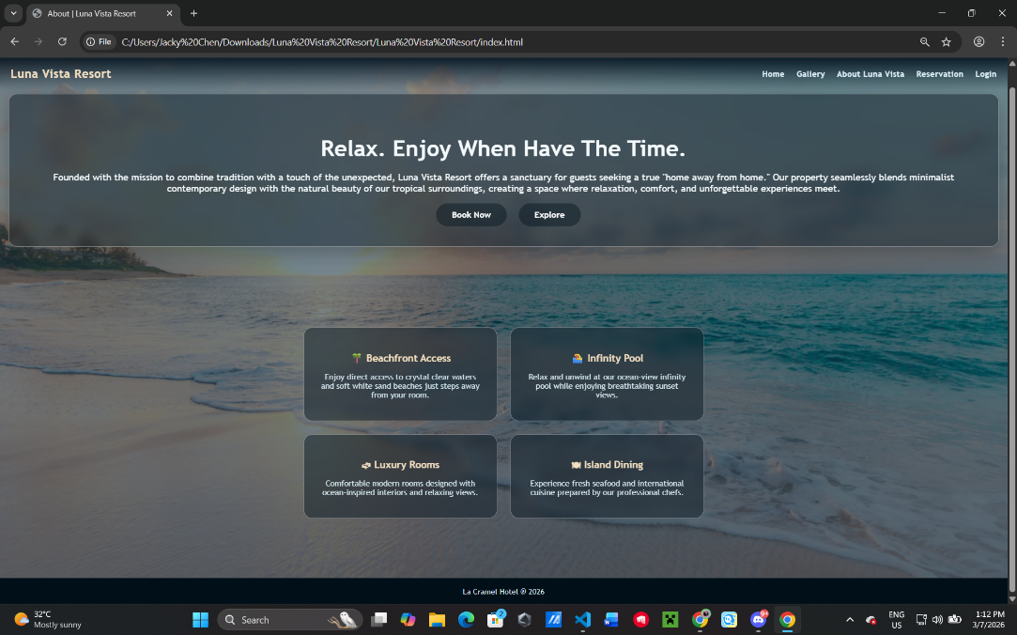

Index

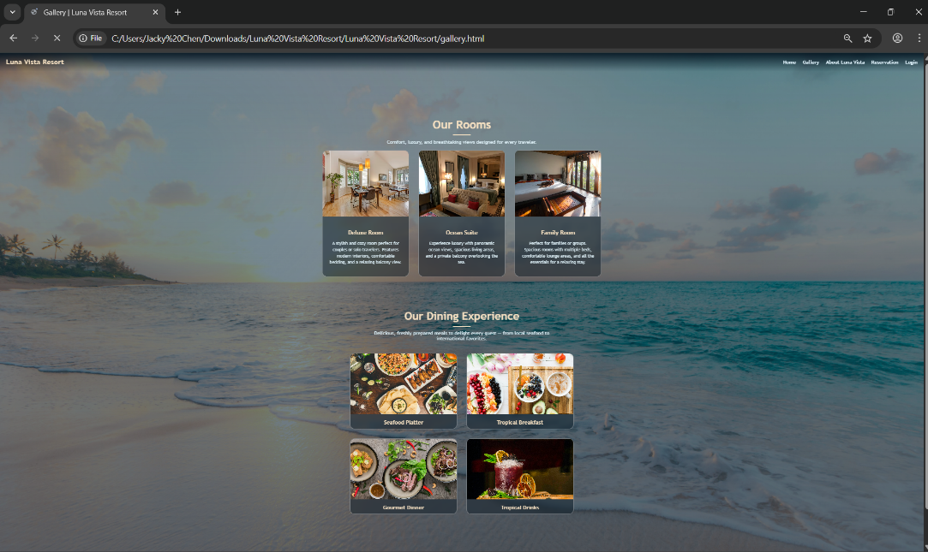
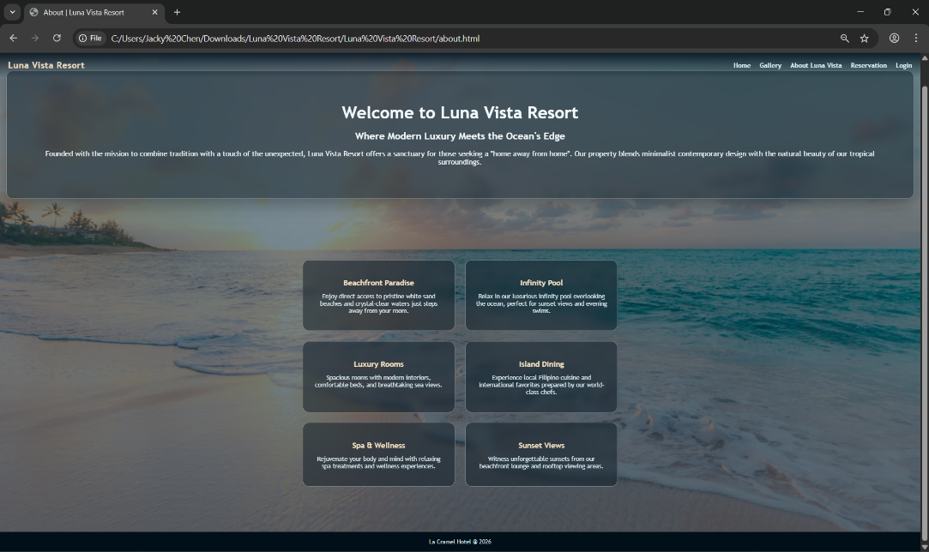

Gallery

About

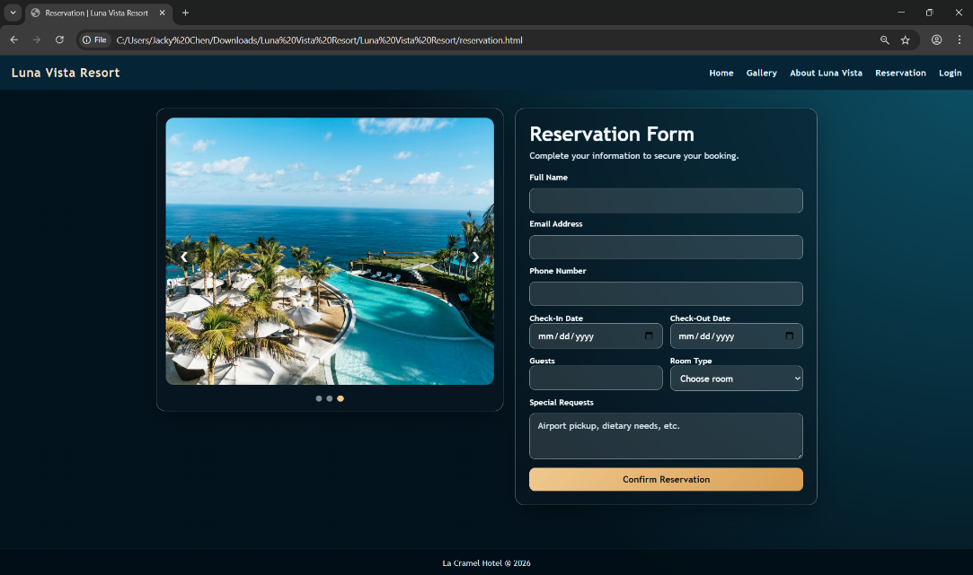
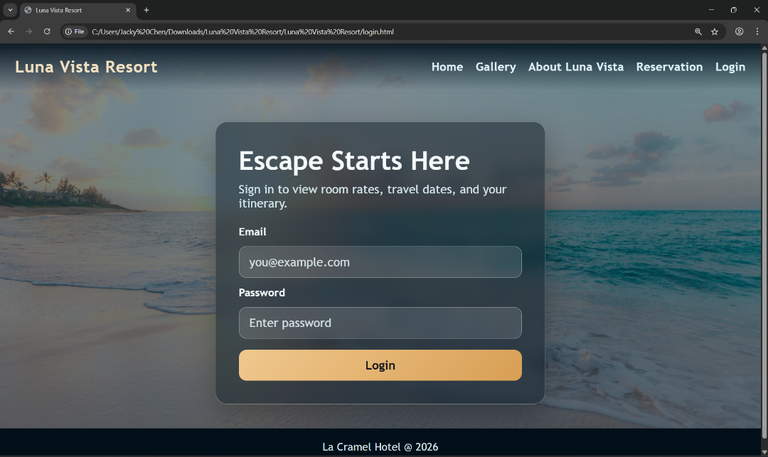

Reservation

Login

